Ask the Sheriff!

How many defenseless kids has he pepper-sprayed?
How many women in the shower do his guards watch?
How many have died and are dying of abuse?
How many lawsuits--at what cost to the county?
How long can we put up with this?
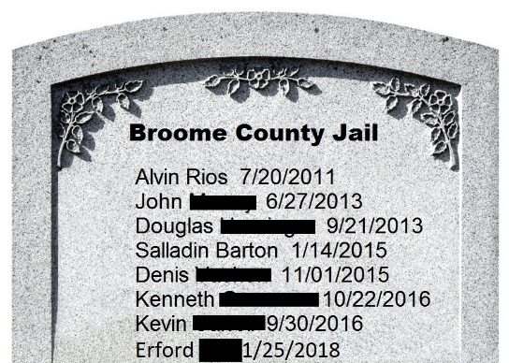

Join the Rally for Justice
Outside the Sheriff's Reelection Party
Thursday April 19th 5pm
81 State Street

Sponsored by Justice and Unity for the Southern Tier (JUST)

